Top Online Content Example – Month/Year
Note: These metrics are for example purposes only

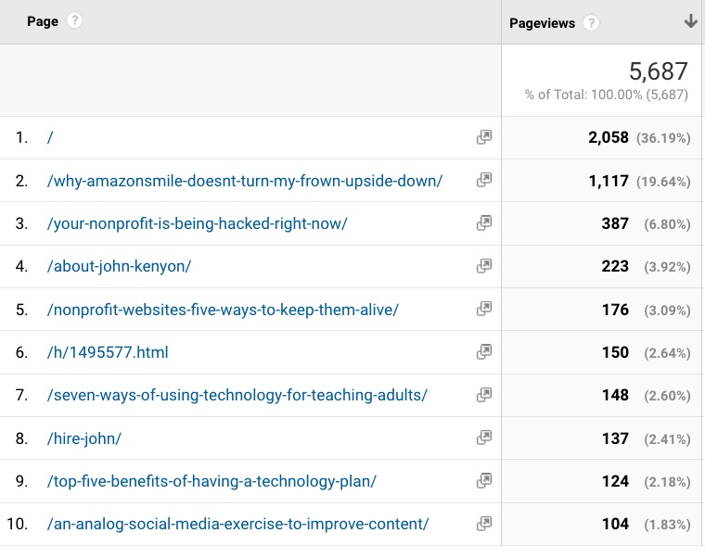
Website

In this example from my website, after the home page I can see which topics got the most traffic from my online audience.

Looking at these metrics every month lets me know what my online community is most interested in. I’ll plan to create more content about popular topics like cybersecurity, charity malls and website. I’ll try new topics too.

Also look at your least visited pages and either improve or delete them if they don’t work.

Email
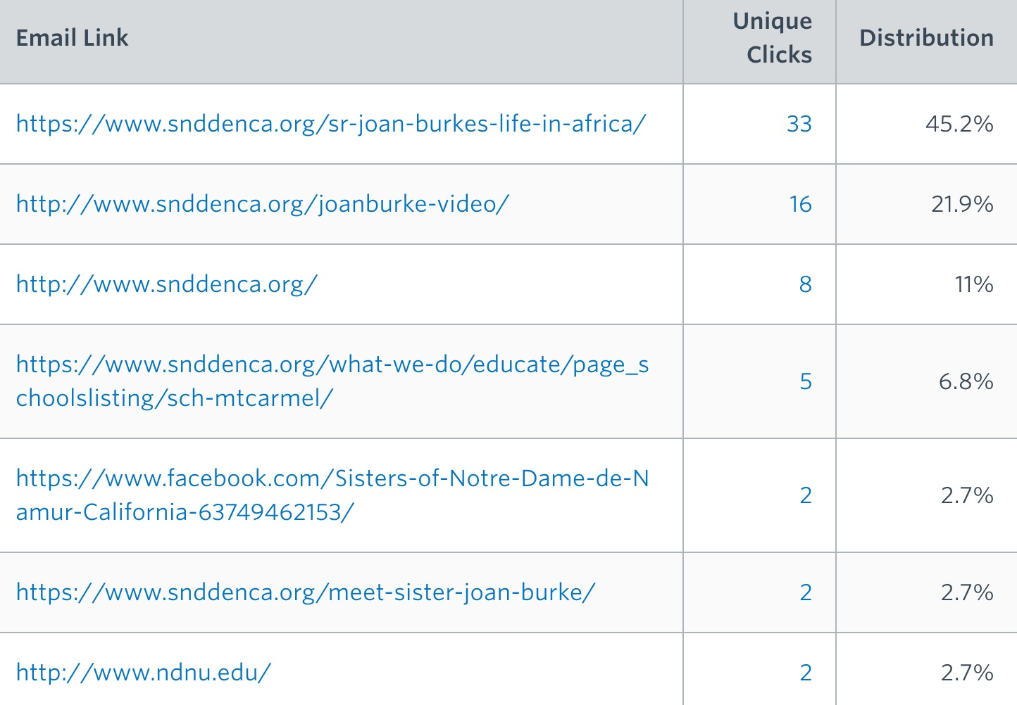
This shows the most clicked links from an enewsletter.
If you look across several months of emails at what your most clicked links are, you can start to understand what topics are most interesting to your online audience. You can then plan to produce more content on those topics.

Look at what folks don’t click on too and do less of that or find other ways to describe it to get folks clicking.

Social Media

Top social media posts, gathered from Facebook Insights and Twitter Analytics:

Facebook

Event Tickets on Sale Now 8 shares, 14 clicks
Meet our Board Chair 2 shares, 23 clicks
Video of our client Juanita 87 views, 29 clicks

Twitter

Video of our client Juanita 6 retweets, 16 clicks
Meet our keynote speaker John Kenyon 9 retweets, 12 clicks

